AGU <x99> SUMMER INTERNSHIP
REPORT
SUBMITTED TO
THE DEPARTMENT OF INDUSTRIAL ENGINEERING OF
ABDULLAH GUL UNIVERSITY
IN PARTIAL FULLFILLMENT OF THE REQUIREMENTS
FOR THE DEGREE OF BACHELOR OF SCIENCE
<Company Name>
<Internship Dates>
By
<Student Name>
<Student ID Number>
<Date of the Submission>
Kayseri / TURKEY

SUMMARY
This section provides an overview of your entire report. Hence, it is recommended that you do not write this chapter before you finish writing the rest of your report. Your summary should be descriptive of the work you did during the “Preparation for Professional Life” program. Do not copy and paste sentences from the body of your report: summarize what is contained in this report with new sentences. Introduce the company, the department you worked in, and the dates of your employment. Very briefly, summarize your participation in company operations and your contributions. Do not exceed 150 words.
This document is prepared to help you in preparing your final reports. Each section contains formatting as well as content guidelines related to that section. You can use this file as a template if you write your report using MS Word. In case you choose to typeset your reports using another application, we give some formatting guidelines in the remainder of this chapter.
- The report must be written on white, high quality, opaque A4 paper.
- Use Times New Roman 12 pt. throughout the report.
- There must be page numbers on each page, except the cover page (it has the number i, but it should not be printed out. The next page would be page ii). Until the first section of text (i.e., introduction) the page numbers should be in lower-case roman numerals (i, ii, iii, …). The text of the report, starting from Section 1 until the end, should have page numbers in Arabic numerals (1, 2, 3, …).
- Paragraphs must be justified, must have 1.5 line spacing and must have 18 pt. space at the end before the next paragraph begins. No indentation must be done at the start of each paragraph. Likewise, leave 18 pt. space after the titles of the sections and subsections.

TABLE OF CONTENTS

TABLE OF CONTENTS iii
LIST OF FIGURES iv
LIST OF TABLES v
1. INTRODUCTION 1
2. THE SYSTEM UNDER CONSIDERATION 2
3. METHODOLOGY 4
3.1. Problem Analysis 4
3.2. Literature Review 4
3.3. The Proposed Model 4
4. CONCLUSION 5
5. BIBLIOGRAPHY 5
APPENDICES 7

The table of contents should begin on a new page. We recommend that you prepare your table of contents using MS Word Table of Contents tools.
The "TABLE OF CONTENTS" title must be in Times New Roman font, capitalized and centered. The table of contents entries must start with itself, and the table of contents must exclude the summary, and cover page. The entries in the contents should match the section, subsection, and sub-subsections exactly. The section titles must be capitalized, in 12 pt. bold font; the subsection titles must be written using indentation, capitalized, regular (i.e. not bold), 12 pt. font; the sub-subsections must be intended further from the subsections, written in italics using 10 pt. font. All the section, subsection, sub-subsection should be numbered.

LIST OF FIGURES
Figure 1. Process Chart 3
Figure 2. Production Line 3
The list of figures should begin on a new page and present a list of figures including page numbers. We recommend that you prepare your list of figures using MS Word tools. Remember to put numbers and captions on the figures: i.e., you should name all your figures. Captions are small description of what is seen in the figure. Numbers and names of the figures should be placed at the bottom of the figures. See examples below.

LIST OF TABLES
Table 1. Time Study Results 5
The list of tables should begin on a new page and give a list of tables including page numbers. We recommend that you prepare your list of tables using MS Word tools. Remember to put numbers and captions on the tables: you should name all your tables. Captions are small description of what is seen in the table. Numbers and names of the tables should be placed at the top of the tables. See examples below.

- INTRODUCTION
This section should start on a new page. In the introduction part, you should provide brief information about the company. This section should not exceed two pages. Here is a list to help you what you inform the reader about the company:
- company name,
- products / services,
- company location,
- date of establishment,
- ownership,
- outdoors and indoors area (m²),
- staff composition: number of white-collar and blue-collar workers,
- the number and positions of industrial engineers in the company,
- the annual production capacity of major products/services, and the average utilized capacity,
- market share,
- and major competitors.
Keep in mind that this list is not exhaustive. Neither should the items be treated as questions to be answered item by item in text. Rather, treat this list as key points to be discussed in the introduction. In doing so, it is important that you do not use these items as “filler material.” It is up to your discretion whether an item needs to be discussed or not. For example, outdoors and indoors area of a bank branch is probably not relevant to the operations of the department of commercial loans; hence you may omit that item. On the other hand, if your work is specifically related to the planning of the flow of materials and information within that particular branch, then the area will probably be a relevant aspect; hence, you need to include that item.
You need to use your words and sentences throughout the report. This applies to the introduction section as well: avoid copying and pasting sentences from websites. If you have to include something in your report verbatim, put the included part inside quotation marks. Also remember that if you are use anything from an outside source, be it verbatim or by paraphrasing, you should provide a reference to the source in the “Bibliography” section and cite the reference in the text. In particular, all the articles, books, internet sites that are used should be cited in text and these sources should be listed in the bibliography. The items that are not referred in text should not be listed in the bibliography section. References you cite here and in other sections of the report should be combined into a numbered list in the bibliography. When citing a reference in text, use one of the following forms:
“Longaray [15] classifies the scientific research process in five dimensions: knowledge vision, scientific paradigm, research strategy, research method and instruments.”
or
“The scientific research process has been classified in five dimensions: knowledge, vision, scientific paradigm, research strategy, research method and instruments [15].”
Of course Longaray’s paper should be number 15 in bibliography.
For maintaining a bibliography and citing references, you can use the MS Word “Citations and Bibliography” tool (under the References ribbon). Follow the IEEE Citation Reference Standard (Style: IEEE) if you use MS Word bibliography tools. For more information on how to use MS Word Reference tool, follow the following URL: https://support.office.com/en-us/article/Create-a-bibliography-3403c027-96c8-40d3-a386-bfd5c413ddbb
- THE SYSTEM UNDER CONSIDERATION
Begin this section by explaining the current status of the system. You should explain and analyze the production or service system from an industrial engineering perspective. For example, for a manufacturing company, track the manufacturing and material handling processes starting from the entry of raw materials until the shipment of the end products. For a company where customers are served (e.g., a bank, and a hospital), track the customers from the point they enter to the system until the point they leave the system. Pay specific attention to who/when/where/how the decisions are made and how the decisions are executed. Include necessary charts and diagrams. Make sure that text on figures are also in English. This “big picture” part of the section should not exceed three pages.
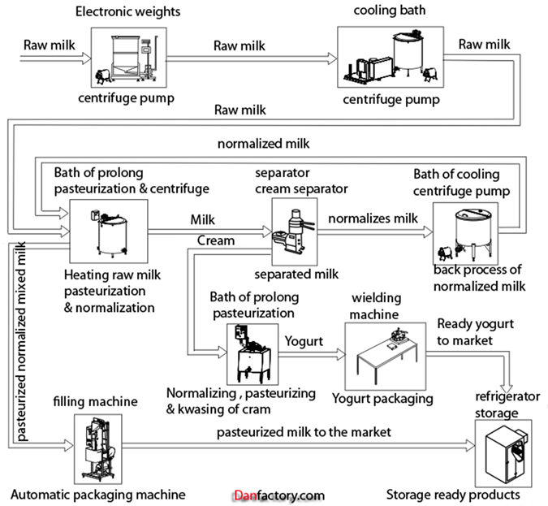
Figure 1. Process Chart
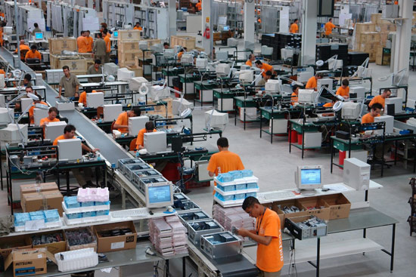
Figure 2. Production Line
After explaining the big picture discussed above, analyze the picture to find an area of improvement and focus there. Define an industrial engineering or operations research problem, whose solution will help you or the decision-maker to achieve the aimed improvement. Give the motivation and justification of the problem. Make sure to include a clear problem definition, and explanation of what can be improved and why this problem is important for the company.
- METHODOLOGY
Analyze the defined problem by supporting with relevant data. Develop a model that can be used to solve the problem to optimize the specified performance measure(s). During this process, conduct a literature survey to search for alternative modeling and solution approaches that can be adopted for your problem. You can arrange the material in this section into several subsections. For example, “Problem Analysis,” “Literature Review,” “Model Development,” “Results,” and so forth.
  - Problem Analysis
This subsection is added so that you can see how it is included in the table of contents. Your own title may change.
  - Literature Review
This subsection is added so that you can see how it is included in the table of contents. Your own title may change.
  - The Proposed Model
This subsection is added so that you can see how it is included in the table of contents. Your own title may change.
In Sections 2 and 3, the problem may already have been noticed by the company before your start to the program, and a project may have already been launched to address the problem. In this case, you may be assigned to a team that has been tasked with addressing the problem. If this is not the case, you need to define and analyze the problem yourself. If you have worked in a group in an existing project, give information about the team: Who were in the group? Give names, and positions in the firm. Specify if they are industrial engineers. Describe each person’s contribution (including yours). Describe your role in details. Whether you have studied in a group in an existing project or not, i.e., in both cases, do not just write that you have made an analysis: provide details of your work, and justify your data, if collected. Explain the methods you used in your analysis and indicate your data collection techniques. Summarize your results with necessary figures and tables. If the project was finished and put in use within the time period that you spend during the program, explain the results. Did everything go as planned? Did the project achieve the anticipated improvement(s)? If the solution was not ready before you leave the company, or you are proposing a solution yourself anew, make your best projections about the results. If you are proposing a solution yourself, make also sure to discuss your formulation of the problem and the solution methodology with your company advisors to increase their viability in practice and seek the possibility to apply your solution.
Table 1. Time Study Results
Observation No | Observer’s Rating  (%) | Observation Time (minutes) | Standard Time (minutes) | Actual Rating (%) | Difference
1
2
3
…
- CONCLUSION
This section is an overall assessment of the work you carried out. Give an interpretation of your results, if you have any. What do they mean? What are the shortcomings of your work? Did you have to make some assumptions which might alter the real behavior of the system you are analyzing? What kind of conclusions did you reach? How can your study be improved? What else could be done? What are your contributions to the company? Did you participate in making an improvement? What did you gain from this program? Your conclusions should not exceed two pages.
- BIBLIOGRAPHY
This section should give a numbered list of references that were cited in text. The source you did not explicitly cite in text should not appear here: “I’ve read this book and generally found it useful when preparing this report” is not acceptable. Each reference here should have been cited in text. Your references list should be sorted in alphabetical order using the last names of the first author. Please note that books, papers, thesis etc. have different formats. While writing the references follow one of the well-known guidelines consistently (e.g. APA, MLA, Turabian, Chicago, AMA, and Harvard). You can also use MS Word Bibliography tools. If you choose to do so, use IEEE format. An example bibliography is given below:
- S. Andradottir, “Simulation Optimization,” In: J. Banks (Eds.), Handbook of simulation: Principles, methodology, advances, applications, and practice. NJ, USA: John Wiley, 2007.
- M.C. Fu, “Optimization for simulation: Theory vs. practice,” INFORMS Journal on Computing, 14, 192−215, 2002.
- J.P.C. Kleijnen, Design and analysis of simulation experiments. NY, USA: Springer-Verlag, 2008.
- A.M. Law, Simulation modeling and analysis, 5th edition, McGraw-Hill, 2014.
- E. Tekin, E., I.Sabuncuoglu, “Simulation optimization: A comprehensive review on theory and applications,” IIE Transactions, 36, 1067−108, 2004.
- …

APPENDICES
This section should start on a new page. If you have more than one subsection here, the title of this section should be in plural: Appendices, otherwise it should be “Appendix.” In the case of multiple appendices, number each appendix and give each a title: For example, “Appendix A1. Photographs from the Shop Floor,” “Appendix A2. An Example Order Release Form,” and so forth. Add all supplementary material that is not directly related to your discussions and would otherwise disturb the flow of the exposition of the material to this section.

