

THESIS WRITING GUIDELINES

1. **Paper Type**

The thesis must be written on a white, high quality, opaque A4 paper of which a single brand of paper manufacturer is used throughout the thesis.

1. **Text font and style**

The thesis must be written using Times New Roman. The font size should be 12 throughout the text. See the related titles in the manual for the special font size and style.

1. **Margins**

All text must be justified and the margins should be 3.5 cm from the left, 2.5 cm from the right, top and bottom.

1. **Spacing**

The thesis must be written using 1.5 line spacing. Single spacing must be used for figure and table captions, figure and table names in the contents, bibliography and footnotes. The chapter titles must have four single spaces above them; headings have triple spaces above and below; sub headings have double space above and below.

1. **Indentation**

Indentation must be done at the start of each chapter text and at each the paragraph using the tab margins, with 1 cm indentation.

1. **Pagination**

Starting with the “abstract” page, there must be a page number on each page of the thesis. The cover page, approvals page, and dedication page do not include pagination. Lower-case Roman numerals (i, ii, iii, etc.) must be used starting the “abstract” pages, followed by the acknowledgments, the table of contents, the list of figures, and the list of tables. Arabic numerals (1, 2, 3, …) are used from the beginning of the first chapter and must run consecutively until the last page of the thesis. The page numbers must be placed at the bottom of each page, centered.

1. **Abstract**

The thesis contains one abstract in Turkish (özet) and one absract in English, both not to exceed 1 page individually.

The abstract page must start with the title “ABSTRACT” . The title should all be in capital letters. The name and surname of the author, the name of the degree program, the name and title of the supervisor, and the dissertation month and year should follow as in the sample guideline below. Keywords must be placed in italics at the end of each abstract with a maximum of 5 keywords. The abstract and the keywords must be written using 12 pt. fonts.

1. **Dedication Page (optional)**

The dedication page (if being used) must be placed just before the first chapter of the thesis (using optional language).

1. **Acknowledgements**

Acknowledgments must be paginated with lower-case Roman numerals and must fit into a maximum of 1 page.

1. **Table of Contents**

"TABLE OF CONTENTS" title must be in 24 pt. Times New Roman font, capitalized and centered. The table of content entries must start with the first chapter of the text, excluding the abstract, acknowledgement, cover page pagination. The entries in the contents should match exactly with the in text titles, subtitles, sub-subsections.

The title names must be capitalized, in 12 pt.fonts, bold; subtitles must be written using indentation, capitalized, regular (i.e. not bold), 12 pt. fonts; sub-subsections must be intended further from the subsections, written in italics using 10 pt. fonts, only the first character is capitalized.

i.e.,

1. Introduction 1
2. Title 2

2.1 Subtitle 1 2

2.2 Subtitle 2 2

2.3 Subtitle 3 2

2.4 Subtitle 4 3

2.4.1 Sub-subsection 1 3

2.4.2 Sub-subsection 1 3

1. **List of Figures and Tables:** These lists should be arranged similar to the “Table of Contents” format.

i.e.,

Figure 2.3.1 Figure caption 3

The title of the table/figure in the given list must exactly match the pagination and the wording used in the figure/table caption. Single spacing must be used if the caption exceeds single line.

1. **Text**

The thesis organization must follow the table of contents subsection formatting. Each chapter must start with a new page, with the chapter name and title; numbered, the first character capitalized, written using 24 pt. fonts. The subtitles and sub-subsections must be written with the first character capitalized, using 18 pt. and 14 pt. fonts, respectively.

1. **Tables and Figures**

The figures and tables used within the thesis must be placed in a stylistic way. The figures must be at high quality graphics format, with all the characters being readable, if any text included. The tables and figures should be numbered consecutively throughout the text. For example, the second figure in the subsection 2.1 should be numbered as Figure. 2.1.2 and the first figure in the sub-subsection 3.2.1 should be numbered as Figure. 3.2.1.1

The captions of the figures and tables must be aligned left, with the first letter capitalized.

1. **Equations and Formulas**

Equations and formulae must be typed using professional software, separated from the text, placed in the middle of the flowing text, with equation numbers placed in the same line of the equation, in bold typeface, using 10 pt. fonts, numbered in a similar fashion of the figures/tables.

1. **Citations**

The citations used in the thesis must be included in the “Bibliography” of the thesis. The bibliography must be placed at the end of the text, before the “Appendix” chapter (if any). The in-text citing of the references in the bibliography should follow the Arabic numbers in the brackets. i.e., [], [1,3], [4-8]. The format of the citations must be in the following format:

Books: A. Demir, “Name of the book,” Publisher (year).

Articles: A. Demir, B. Bakır, C. Çinko, "Name of the article," Journal of Xxx, volume no, page no (year).

Web sources: Tile of the source, http://www.websource.com (Date of access)

Thesis submitted to Arch Program should use the following citation format: Surname, year (as in the APA format)

1. **Appendix**

Appendices (if any) must be placed at the end of the thesis, after the “Bibliography”.

FRONT COVER AND SPINE

|  |  |
| --- | --- |
| Name Surname | TITLE OF THE THESIS  A THESIS  SUBMITTED TO THE DEPARTMENT OF XXX  AND THE GRADUATE SCHOOL OF ENGINEERING AND SCIENCE OF ABDULLAH GUL UNIVERSITY  IN PARTIAL FULFILLMENT OF THE REQUIREMENTS  FOR THE DEGREE OF  XXX  By  Name Surname  Month Year |
| THESIS TITLE  THESIS TITLE |
| AGU  Year |

TITLE OF THE THESIS

A THESIS

SUBMITTED TO THE DEPARTMENT OF XXX

AND THE GRADUATE SCHOOL OF ENGINEERING AND SCIENCE OF ABDULLAH GUL UNIVERSITY

IN PARTIAL FULFILLMENT OF THE REQUIREMENTS

FOR THE DEGREE OF

XXX

By

Name Surname

Month Year

**SCIENTIFIC ETHICS COMPLIANCE**

I hereby declare that all information in this document has been obtained in accordance with academic rules and ethical conduct. I also declare that, as required by these rules and conduct, I have fully cited and referenced all materials and results that are not original to this work.

Name-Surname:

Signature :

**REGULATORY COMPLIANCE**

M.Sc. / Ph.D. (Choose one) thesis titled …………………………………………… has been prepared in accordance with the Thesis Writing Guidelines of the Abdullah Gül University, Graduate School of Engineering & Science.

Prepared By Advisor

Name Surname, Signature Name Surname, Signature

Head of the …………………………………………. Program

Name-Surname

Signature

**ACCEPTANCE AND APPROVAL**

M.Sc. / Ph.D. (Choose one) thesis titled …………………………………. and prepared by ………………………… has been accepted by the jury in the …………………………………….. Graduate Program at Abdullah Gül University, Graduate School of Engineering & Science.

……….. /……….. / ………..

(Thesis Defense Exam Date)

**JURY:**

Advisor :………………………………. signature

Member :………………………………. signature

Member :………………………………. signature

Member :………………………………. signature

Member :………………………………. signature

**APPROVAL:**

The acceptance of this M.Sc./Ph.D. (choose one) thesis has been approved by the decision of the Abdullah Gül University, Graduate School of Engineering & Science, Executive Board dated ….. /….. / ……….. and numbered .…………..……. .

……….. /……….. / ………..

**(Date)**

Graduate School Dean Name-Surname, Signature

ABSTRACT

TITLE

Name Surname

MSc./Ph.D. in XXX

**Supervisor:** Title Name/Surname

Month Year

Times New Roman 12

*Keywords: Keyword1, Keyword2,...*

ÖZET

BAŞLIK

Ad-Soyad

XXX Bölümü Doktora/Yüksek Lisans

Tez Yöneticisi: XXX

Ay-Yıl

Times New Roman 12

*Anahtar kelimeler: Anahtar Kelime 1, Anahtar Kelime 2*

**Acknowledgements**

Text

**Table of Contents**

1. Introduction 1
2. Title 2

2.1 Subtitle 1 2

2.2 Subtitle 2 2

2.3 Subtitle 3 2

2.4 Subtitle 4 3

2.4.1 Sub-subsection 1 3

2.4.2 Sub-subsection 1 3

1. Title 4

3.1 Title 1 4

3.1.1 Derivation of XXX 4

1. Title 5

4.1 Title 5

1. Conclusions 7

**List of Figures**

Figure 2.3.1 Figure caption 3

**List of Tables**

Table 4.2.1 Figure caption 6

*To xxx,yyy*

**Chapter 1**

# Introduction

Text

**Chapter 2**

# Title

Text

## 2.1 Subtitle 1

Text

## 2.2 Subtitle 2

Text

## 2.3 Subtitle 3

Text

|  |  |
| --- | --- |
|  | (2.3.1) |

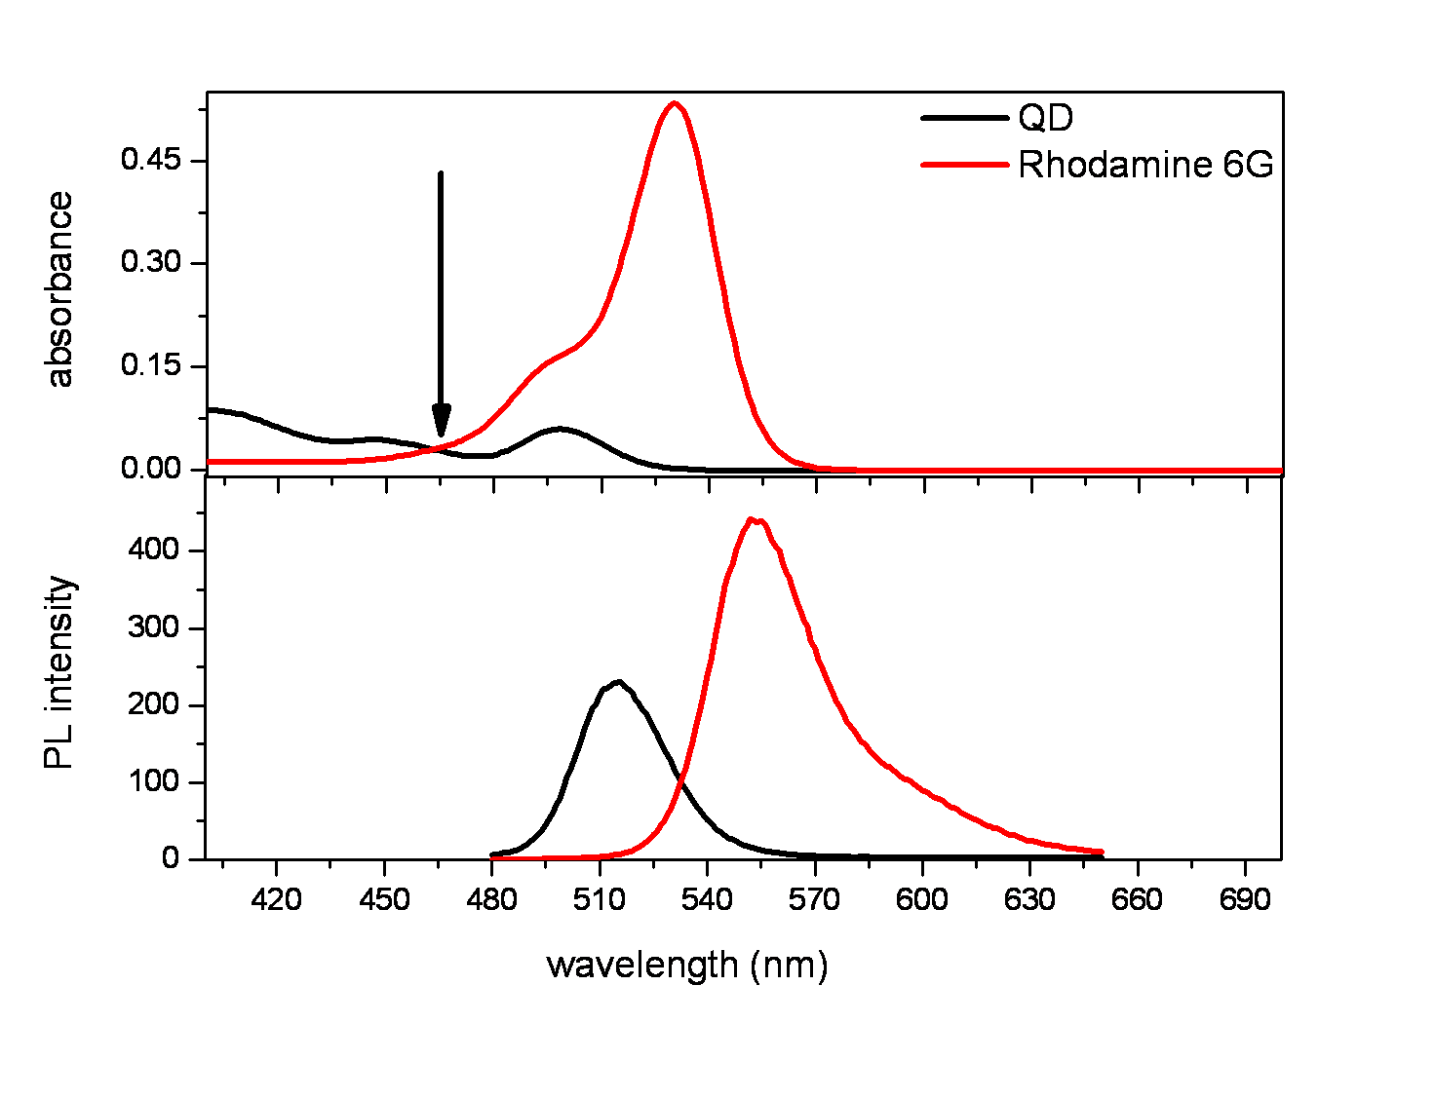

Figure 2.3.1 Figure caption

## 2.4 Subtitle 4

Text

### 2.4.1 Sub-subsection 1

Text

### 2.4.2 Sub-subsection 1

Text

**Chapter 3**

# Title

## 3.1 Title 1

Text

### 3.1.1 Derivation of XXX

Text [[1]],



4.2.1.1

**Chapter 4**

# Title

Text

## 4.1 Title

Text

.

|  |  |  |  |  |  |  |  |  |  |
| --- | --- | --- | --- | --- | --- | --- | --- | --- | --- |
| **L**  **A**  **B**  **E**  **L** | Concentration  ratio | Using amine-functionalized donors | | | | Using non-functionalized donors | | | |
| Quantum yield | | Förster radius | | Quantum yield | | Förster radius | |
| 29.5% | | 5.6 nm | | 33.5% | | 5.6 nm | |
| Lifetime analysis | | | | Lifetime analysis | | | |
| **A/D** | τi | **χ2** | | ηFRET | τi | **χ2** | | ηFRET |
| **a** | **0.00** | **18.16** | 1.09 | | - | **16.65** | 1.08 | | - |
| **b** | **1.03** | **15.79** | 1.15 | | 37 | **15.83** | 1.08 | | 9 |
| **c** | **3.34** | **15.44** | 1.14 | | 38 | **13.97** | 1.15 | | 28 |
| **d** | **5.90** | **11.49** | 1.22 | | 71 | **12.29** | 1.22 | | 42 |
| **e** | **8.98** | **8.94** | 1.24 | | 80 | **10.45** | 1.26 | | 56 |
| **f** | **13.09** | **6.32** | 1.31 | | 86 | **8.67** | 1.28 | | 65 |
| **g** | **17.20** | **3.99** | 1.27 | | 89 | **7.88** | 1.31 | | 68 |
| **h** | **21.30** | **2.87** | 1.26 | | 91 | **6.47** | 1.38 | | 75 |
| **i** | **25.41** | **2.51** | 1.25 | | 92 | **5.88** | 1.39 | | 79 |
| **j** | **29.52** | **2.13** | 1.23 | | 93 | **5.13** | 1.26 | | 79 |
| **k** | **37.73** | **1.94** | 1.14 | | 94 | **4.52** | 1.32 | | 83 |
| **l** | **45.94** | **1.88** | 1.20 | | 94 | **3.82** | 1.32 | | 86 |

Table 4.2.1 Figure caption

**Chapter X**

# Conclusions and Future Prospects

## X.1 Conclusions

Text

## X.2 Future Prospects

Text

**BIBLIOGRAPHY**

1. [] J. J. Jackson, “Classical Electrodynamics,” Wiley (1998).

   [2] E. Mutlugun, P. L. Hernandez-Martinez, C. Eroğlu, Y. Coşkun, T. Erdem, V. K. Sharma, E. Ünal, S. K. Panda, S. G. Hickey, N. Gaponik, A. Eychmuller and H. V. Demir, "Large-area (over 50 cm × 50 cm) freestanding films of colloidal InP/ZnS quantum dots," Nano Letters, 12, 3986 (2012).

   [3] Lindeberg-Feller Central Limit Theorem, http://www.opentrading

   system.com/quantNotes/LindebergFellercentrallimittheorem.html (Date of access)

   **APPENDIX**

   # Title

   Text