

THESIS WRITING GUIDELINES

1. **Paper Type**

The thesis must be written on a white, high quality, opaque A4 paper of which a single brand of paper manufacturer is used throughout the thesis.

1. **Text Font and Style**

The thesis must be written using Times New Roman. The font size should be 12 throughout the text. See the related titles in the manual for the special font size and style.

1. **Margins**

All text must be justified, and the margins should be 3.5 cm from the left, 2.5 cm from the right, top and bottom.

1. **Spacing**

The thesis must be written using 1.5 line spacing. Single spacing must be used for figure and table captions, figure and table names in the contents, bibliography, and footnotes. The chapter titles must have three single spaces above them; headings have double spaces above and below; subheadings have single space above and below.

1. **Indentation**

Indentation must be done at the start of each chapter text and at each the paragraph using the tab margins, with 1 cm indentation.

1. **Pagination**

Starting with the “abstract” page, there must be a page number on each page of the thesis. The cover page, approvals page, and dedication page do not include pagination. Lower-case Roman numerals (i, ii, iii, etc.) must be used starting the “abstract” pages, followed by the acknowledgments, the table of contents, the list of figures, and the list of tables. Arabic numerals (1, 2, 3, …) are used from the beginning of the first chapter and must run consecutively until the last page of the thesis. The page numbers must be placed at the bottom of each page, centered.

1. **Abstract**

The thesis contains one abstract in Turkish (özet) and one abstract in English, both not to exceed 1 page individually.

The abstract page must start with the title “ABSTRACT” . The title should all be in capital letters (16 pt. fonts). The name and surname of the author, the name of the degree program, the name and title of the advisor, and the dissertation month and year should follow as in the sample guideline below (12 pt. font). Keywords must be placed in italics at the end of each abstract with a maximum of 5 keywords. The abstract and the keywords must be written using 12 pt. fonts.

Page number style should be lower case Roman numerals from abstract to list of abbreviations parts of thesis.

1. **Dedication Page (optional)**

The dedication page (if being used) must be placed just before the first chapter of the thesis (using optional language).

1. **Acknowledgements**

Acknowledgements must be paginated with lower-case Roman numerals and must fit into a maximum of 1 page. (Title: 24 pt. fonts, text: 12 pt. fonts)

1. **Table of Contents**

"TABLE OF CONTENTS" title must be in 24 pt. Times New Roman font, capitalized and centered. The table of content entries must start with the first chapter of the text, excluding the abstract, acknowledgement, cover page pagination. The entries in the contents should match exactly with the in text titles, subtitles, sub-subsections.

The title names must be capitalized, in 12 pt. fonts, bold; subtitles must be written using indentation, capitalized, regular (i.e., not bold), 12 pt. fonts; sub-subsections must be intended further from the subsections, written in italics using 12 pt. fonts, only the first character is capitalized.

1. **List of Figures and Tables**

**“LIST OF FIGURES” and “LIST OF TABLES”** titles must be in 24 pt. Times New Roman font, capitalized and centered.These lists should be arranged similar to the “Table of Contents” format.

i.e.,

Figure 2.3 Figure caption 3

The title of the table/figure in the given list must exactly match the pagination and the wording used in the figure/table caption. Single spacing must be used if the caption exceeds single line.

1. **List of Abbreviations**

Title must be in 24 pt. Times New Roman font, capitalized and centered Abbreviation should be ordered alphabetically (12 pt. font). If included, you should follow a format consistent with acceptable practice in your discipline.

1. **Text**

The thesis organization must follow the table of contents subsection formatting. Each chapter must start with a new page, with the chapter name and title; numbered, the first character capitalized, written using 24 pt. fonts. The subtitles and sub-subsections must be written with the first character capitalized, using 18 pt. and 14 pt. fonts, respectively.

1. **Tables and Figures**

The figures and tables used within the thesis must be placed in a stylistic way. The figures must be at high quality graphics format, with all the characters being readable, if any text included. The tables and figures should be numbered consecutively throughout the text. For example, the second figure/table in the section 2 should be numbered as Figure 2.2/Table 2.2 and the first figure/table in the section 3 should be numbered as Figure 3.1/Table 3.1. The figure and table captions should be written using Times New Roman, and the font size should be 12. The captions of the figures and tables must be aligned left, with the first letter capitalized.

1. **Equations and Formulas**

Equations and formulae must be typed using professional software, separated from the text, placed in the middle of the flowing text, with equation numbers placed in the same line of the equation, in bold typeface, using 10 pt. fonts, numbered in a similar fashion of the figures/tables.

1. **Citations**

The citations used in the thesis must be included in the “Bibliography” of the thesis. The bibliography must be placed at the end of the text, before the “Appendix” chapter (if any). The in-text citing of the references in the bibliography should follow the Arabic numbers in the brackets. i.e., [], [1,3], [4-8]. The format of the citations must be in the following format:

Books: A. Demir, “Name of the book,” Publisher (year).

Articles: A. Demir, B. Bakır, C. Çinko, "Name of the article," Journal of Xxx, volume no, page no (year).

Web sources: Tile of the source, http://www.websource.com (Date of access)

Thesis submitted to Arch Program should use the following citation format: Surname, year (as in the APA format)

1. **Appendix**

Appendices (if any) must be placed at the end of the thesis, after the “Bibliography”.

1. **Curriculum Vitae (CV)**

CV is a professional biography of the candidate which includes educational institutions attended (after high school), degrees and honors won, titles of publications, and teaching and professional experience. It should be short, concise, and written in the third person. CV must be in the same font and point size as the rest of the thesis.

FRONT COVER AND SPINE

|  |  |
| --- | --- |
| Name Surname | TITLE OF THE THESIS  A THESIS  SUBMITTED TO THE DEPARTMENT OF XXX  AND THE GRADUATE SCHOOL OF ENGINEERING AND SCIENCE OF ABDULLAH GUL UNIVERSITY  IN PARTIAL FULFILLMENT OF THE REQUIREMENTS  FOR THE DEGREE OF  XXX  By  Name Surname  Month Year |
| A Master’s Thesis / A Ph.D. Thesis |
| AGU Year |

TITLE OF THE THESIS

A THESIS

SUBMITTED TO THE DEPARTMENT OF XXX

AND THE GRADUATE SCHOOL OF ENGINEERING AND SCIENCE OF ABDULLAH GUL UNIVERSITY

IN PARTIAL FULFILLMENT OF THE REQUIREMENTS

FOR THE DEGREE OF

XXX

By

Name Surname

Month Year

**SCIENTIFIC ETHICS COMPLIANCE**

I hereby declare that all information in this document has been obtained in accordance with academic rules and ethical conduct. I also declare that, as required by these rules and conduct, I have fully cited and referenced all materials and results that are not original to this work.

Name-Surname:

Signature :

**REGULATORY COMPLIANCE**

M.Sc. / Ph.D. (Choose one) thesis titled …………………………………………… has been prepared in accordance with the Thesis Writing Guidelines of the Abdullah Gül University, Graduate School of Engineering & Science.

|  |  |
| --- | --- |
| Prepared By | Advisor |
| Name Surname | Name Surname |
| Signature | Signature |

Head of the …………………………………………. Program

Name-Surname

Signature

**ACCEPTANCE AND APPROVAL**

M.Sc. / Ph.D. (Choose one) thesis titled …………………………………. and prepared by ………………………… has been accepted by the jury in the …………………………………….. Graduate Program at Abdullah Gül University, Graduate School of Engineering & Science.

……….. /……….. / ………..

(Thesis Defense Exam Date)

**JURY:**

Advisor : (Name Surname)………………………………................................

Member : (Name Surname)………………………………. ..............................

Member : (Name Surname)………………………………. ..............................

Member : (Name Surname)………………………………. ..............................

Member : (Name Surname)………………………………. ..............................

**APPROVAL:**

The acceptance of this M.Sc./Ph.D. (choose one) thesis has been approved by the decision of the Abdullah Gül University, Graduate School of Engineering & Science, Executive Board dated ….. /….. / ……….. and numbered .…………..……. .

……….. /……….. / ………..

**(Date)**

Graduate School Dean

Prof. Dr. Hakan USTA

ABSTRACT

TITLE

Name Surname

MSc./Ph.D. in XXX

Advisor:Title Name/Surname

Month Year

Times New Roman 12

*Keywords: Keyword1, Keyword2,... (max 5 keywords)*

ÖZET

BAŞLIK

Adı-Soyadı

XXX Anabilim Dalı Doktora/Yüksek Lisans

Tez Yöneticisi: XXX

Ay-Yıl

Times New Roman 12

*Anahtar kelimeler: Anahtar Kelime 1, Anahtar Kelime 2*

**Acknowledgements**

Text

**TABLE OF CONTENTS**

1. Introduction 1
2. Title 2

2.1 Subtitle 1 2

2.2 Subtitle 2 2

2.3 Subtitle 3 2

2.4 Subtitle 4 3

2.4.1 Sub-subsection 1 3

2.4.2 Sub-subsection 1 3

1. Title 4

3.1 Title 1 4

3.1.1 Derivation of XXX 4

1. Title 5

4.1 Title 5

1. Conclusions and Future Prospects 6

X.1 Conclusions 6

X.2 Societal Impact and Contribution to Global Sustainability *(Minimum 300 words)* 6

X.3 Future Prospects 6

**LIST OF FIGURES**

Figure 2.1 Figure caption 3

**LIST OF TABLES**

Table 4.1 Table caption 5

**LIST OF ABBREVIATIONS**

|  |  |
| --- | --- |
| AMI | Advanced Metering Infrastructure |
| FHE | Fully Homomorphic Encryption |
| KDC | Key Distribution Center |
| PKC | Public Key Cryptography |
| PKI | Public Key Infrastructure |
| PQC | Post-Quantum Cryptography |
| SG | Smart Grid |
| SMC | Secure Multiparty Computation |

*To xxx,yyy*

**Chapter 1**

# Introduction

Text

**Chapter 2**

# Title

Text

## 2.1 Subtitle 1

Text

## 2.2 Subtitle 2

Text

## 2.3 Subtitle 3

Text

 (2.1)

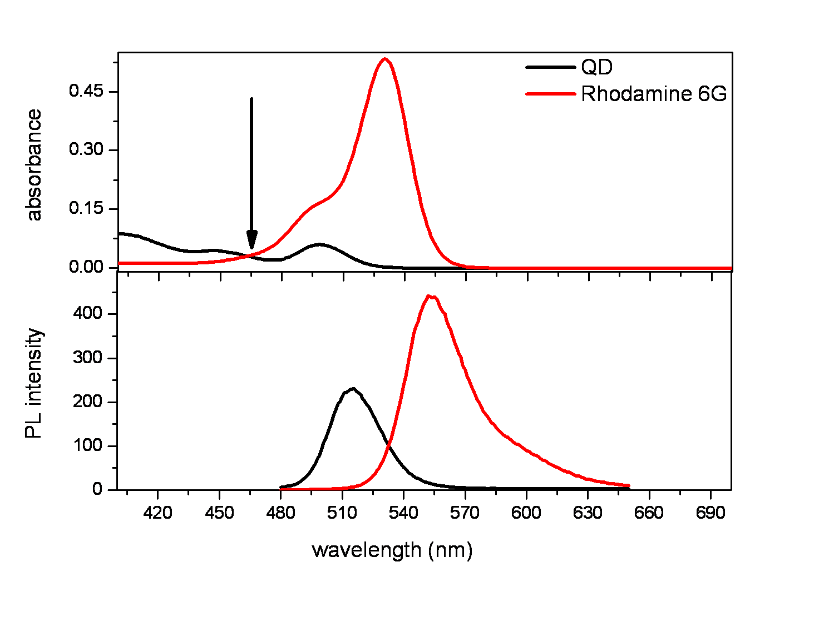

Figure 2.1 Figure caption

## 2.4 Subtitle 4

Text[1]

### 2.4.1 Sub-subsection 1

Text

### 2.4.2 Sub-subsection 1

Text

**Chapter 3**

# Title

## 3.1 Title 1

Text

### 3.1.1 Derivation of XXX

Text [[2]],

 (3.1)

**Chapter 4**

# Title

Text

## 4.1 Title

Text.

Table 4.1 Table caption

|  |  |  |  |  |  |  |  |  |  |
| --- | --- | --- | --- | --- | --- | --- | --- | --- | --- |
| **L**  **A**  **B**  **E**  **L** | Concentration  ratio | Using amine-functionalized donors | | | | Using non-functionalized donors | | | |
| Quantum yield | | Förster radius | | Quantum yield | | Förster radius | |
| 29.5% | | 5.6 nm | | 33.5% | | 5.6 nm | |
| Lifetime analysis | | | | Lifetime analysis | | | |
| **A/D** | τi | **χ2** | | ηFRET | τi | **χ2** | | ηFRET |
| **a** | **0.00** | **18.16** | 1.09 | | - | **16.65** | 1.08 | | - |
| **b** | **1.03** | **15.79** | 1.15 | | 37 | **15.83** | 1.08 | | 9 |
| **c** | **3.34** | **15.44** | 1.14 | | 38 | **13.97** | 1.15 | | 28 |
| **d** | **5.90** | **11.49** | 1.22 | | 71 | **12.29** | 1.22 | | 42 |
| **e** | **8.98** | **8.94** | 1.24 | | 80 | **10.45** | 1.26 | | 56 |
| **f** | **13.09** | **6.32** | 1.31 | | 86 | **8.67** | 1.28 | | 65 |
| **g** | **17.20** | **3.99** | 1.27 | | 89 | **7.88** | 1.31 | | 68 |
| **h** | **21.30** | **2.87** | 1.26 | | 91 | **6.47** | 1.38 | | 75 |
| **i** | **25.41** | **2.51** | 1.25 | | 92 | **5.88** | 1.39 | | 79 |
| **j** | **29.52** | **2.13** | 1.23 | | 93 | **5.13** | 1.26 | | 79 |
| **k** | **37.73** | **1.94** | 1.14 | | 94 | **4.52** | 1.32 | | 83 |
| **l** | **45.94** | **1.88** | 1.20 | | 94 | **3.82** | 1.32 | | 86 |

**Chapter X**

# Conclusions and Future Prospects

## X.1 Conclusions

Text

## X.2 Societal Impact and Contribution to Global Sustainability *(Minimum 300 words)*

Text

## X.3 Future Prospects

Text

**BIBLIOGRAPHY**

1. This is a footnote with single space.
2. [] J. J. Jackson, “Classical Electrodynamics,” Wiley (1998).

   [2] E. Mutlugun, P. L. Hernandez-Martinez, C. Eroğlu, Y. Coşkun, T. Erdem, V. K. Sharma, E. Ünal, S. K. Panda, S. G. Hickey, N. Gaponik, A. Eychmuller and H. V. Demir, "Large-area (over 50 cm × 50 cm) freestanding films of colloidal InP/ZnS quantum dots," Nano Letters, 12, 3986 (2012).

   [3] Lindeberg-Feller Central Limit Theorem, http://www.opentrading

   system.com/quantNotes/LindebergFellercentrallimittheorem.html (Date of access)

   **APPENDIX**

   # Title

   Text

   **CURRICULUM VITAE**

   |  |  |
   | --- | --- |
   | 2006 – 2011 | B.Sc., Computer Engineering, Marmara University, Istanbul, TURKEY |
   | 2011 – 2013 | M.Sc., Computer Engineering, Marmara University, Istanbul, TURKEY |
   | 2015 – 2017 | Doctoral Candidate, Electrical and Computer Engineering, Florida International University, Miami, Florida, USA |
   | 2017 | Award, Dissertation Year Fellowship, Florida International University, Miami, Florida, USA |
   | 2018 | Ph.D., Electrical and Computer Engineering, Florida International University, Miami, Florida, USA |
   | 2018 – Present | Assistant Professor, Electrical and Computer Engineering, Abdullah Gül University, Kayseri, TURKEY |

   SELECTED PUBLICATIONS AND PRESENTATIONS

   **J1)** S. Tonyali, O. Cakmak, K. Akkaya, M.M. Mahmoud, I. Guvenc, Secure Data Obfuscation Scheme to Enable Privacy-Preserving State Estimation in Smart Grid AMI Networks published in IEEE Internet of Things Journal (Oct. 2016).

   **J2)** S. Tonyali, K. Akkaya, N. Saputro, A.S. Uluagac, M. Nojoumian, Privacy-Preserving Protocols for Secure and Reliable Data Aggregation in IoT-Enabled Smart Metering Systems published in Future Generation Computer Systems Journal (Apr.2017).

   **J3)** S. Tonyali, R. Munoz, K. Akkaya, U. Ozgur, A Realistic Performance Evaluation of Privacy-Preserving Protocols for Smart Grid AMI Networks published in Elsevier Journal of Network and Computer Applications (Oct. 2018).

   **C1)** S. Tonyali, N. Saputro, K. Akkaya, Assessing the Feasibility of Fully Homomorphic Encryption for Smart Grid AMI Networks in Proc. of Ubiquitous and Future Networks (Jul. 2015).

   **C2)** S. Tonyali, K. Akkaya, N. Saputro, A.S. Uluagac, A Reliable Data Aggregation Mechanism with Homomorphic Encryption in Smart Grid AMI Networks in Proc. Of IEEE Consumer Communications & Networking Conference (Jan. 2016).