Registration ID Number:

Room Number:

READING & WRITING
FOUNDATION EXEMPTION
EXAMINATION

You have 25 minutes to complete this section.
Please read the questions carefully.

September 2016

Registration #

Foundation Exemption Examination – Reading Text

Read the text and answer the questions of the next page.

Toronto

Toronto is the largest city in Canada. It is the capital city of the province of Ontario. It is on the northwest side
of Lake Ontario. Toronto has a population of more than 5,000,000 people. Canada’s biggest banks have their main
offices in Toronto. It is also a popular destination for tourists. Toronto’s famous CN Tower is the tallest in
the Americas. Toronto is a very multicultural city, because different people from around the world have moved to Toronto to live since the 20th century.

We asked Toronto resident Cengiz about life in the city. Here is what he said.

“What I like most about Toronto is its diverse food. There are also many beautiful parks to visit. The parks have
places where we can eat and play sports. Many people also like to walk their dogs there.”

“The only bad thing about living in Toronto is the cold winters. The temperature can sometimes be -30C. This does not make it fun to go to the park. But we can drive to the mountains to ski or snowboard. Hockey, which is played on ice, is another popular winter sport in Toronto. The city’s hockey team is called the Maple Leafs but the last time
they won the Stanley Cup was 49 years ago!”

The City of Toronto - Fact Sheet

Country Canada
Province Ontario
Districts East York, Etobicoke, North York, Old Toronto, Scarborough, York

Founded August 27, 1793
Incorporated March 6, 1834

Government

• Mayor John Tory
• Council Toronto City Council
• MPs Bill Blair
Carolyn Bennett Arnold Chan
Arif Virani

Area

• City 630 km2 (240 sq mi)
• Urban 1,749 km2 (675 sq mi)
• Metro 5,905 km2 (2,280 sq mi)

Population (2011)

• City (Metro) 5,583,064
• Density 4,149/km2 (10,750/sq mi)

Foundation Exemption Examination – Reading Tasks

Read the text and write the correct answer.

1) Which country is Toronto in?

_____________________________________________________________________________________________

2) Which province does Cengiz live in?

_____________________________________________________________________________________________

3) What is Cengiz’s favourite thing about Toronto?

_____________________________________________________________________________________________

4) What does Cengiz not like about Toronto?

_____________________________________________________________________________________________

5) Where do people like to walk their dogs in Toronto?

_____________________________________________________________________________________________

6) What sport is played on ice?

_____________________________________________________________________________________________

7) What year did the Maple Leafs win their last Stanley Cup?

_____________________________________________________________________________________________

8) How many people live in Toronto?

_____________________________________________________________________________________________

9) Who is the mayor of Toronto?

_____________________________________________________________________________________________

10) Which year was Toronto founded?

_____________________________________________________________________________________________

Foundation Exemption Examination – Writing Task

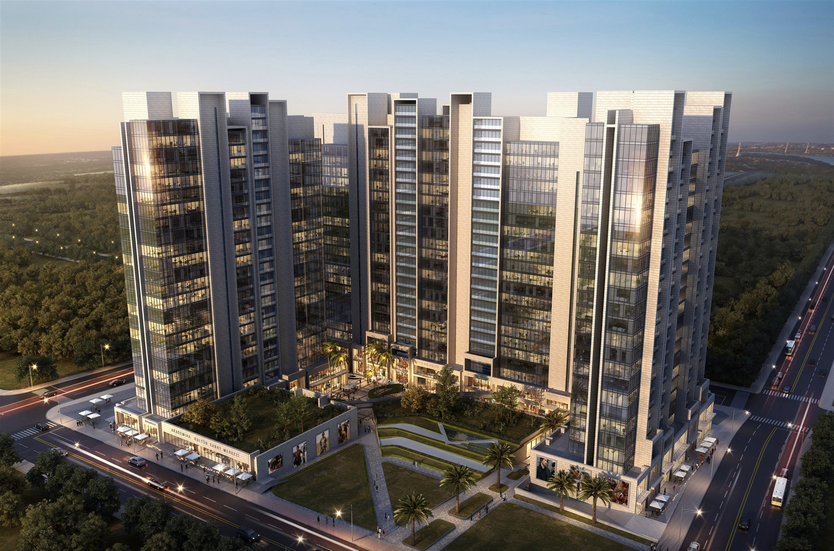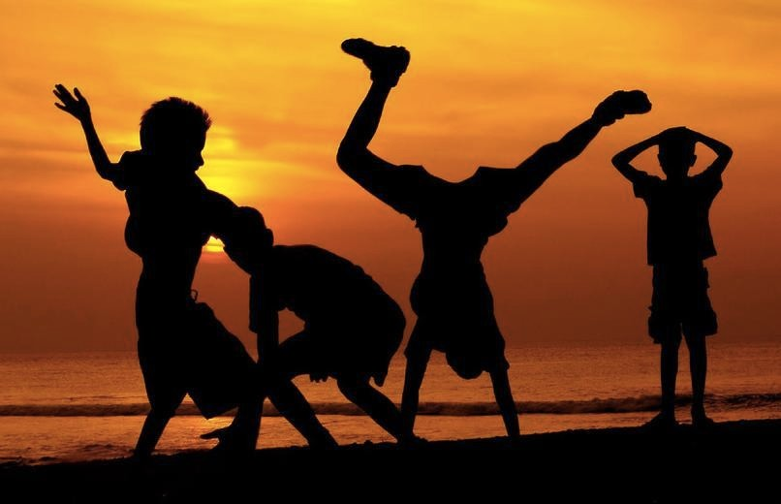Choose ONE picture. Write a paragraph about it.

Picture A Picture B

Tick the box ☐ to show which picture
you are writing about:

☐ Picture A

☐ Picture B

☐ Picture C

Picture C

